Project Description & Parameters

- Problem & Objectives
The project undertaken by Nuts & Bolts aimed to supply an on-online ordering system that simplified the connection between employees and customers. Due to the high cost of subscription-based database applications, Nuts & Bolts aimed to create its own purchasing software. As a result, the company would contain useful information on its customer’s past purchases and redirect its marketing strategy on areas that closely align with their sales.
- Product Structure
The products offered by the Nuts & Bolts application is separated into 3 different divisions: Entertainment, Household and Military. Entertainment robots are comprised of differentiating controllers, shafts, wheels, rivets, motors, nuts, and the sizes of tooth. Household robots are simplified into multiple options with a fixated price. Type A robots are comprised of more simplistic features similar to Rumbas while Type B robots are more complicated in matter; such as automated lawn mowers. Military robots offer a variety of different options and selections including body material, manufacturing specifications, coloring, and specialization features. Specialization features include night vision, zinc electroplating, ultrasonic sensor, guided rockets, demolition charge, or simply a coffee maker. Although certain features would be better suited for certain applications, there are no limits on the customer’s needs.
- Proposed System
The Nuts & Bolts software allows either a customer or an employee to directly log-in to either purchase or summarize depending on the user credentials. The customer has 3 separate divisions to make their purchases from: Entertainment, Household and Military. Each division contains an abundance of options in terms of products and robots for the customer to purchase. The interface itself is user-friendly and allows the customer to switch between different divisions with ease and make multiple purchases if necessary. Finally, the customer has the option to either purchase through a credit card or store those items for a future time under their respective profiles. The employee log-ins are distributed per division and each division’s workers have the option to successfully see the summary of their department’s past.
Entertainment division’s summary includes: Client name, region, order date, component count and total cost. Household division’s summary includes: Client name, region, order date, Type A & B purchases and total cost. The differentiation between Type A & B purchases helps the company identify which locations and customers prefer the higher costing product to better strategize and optimize it’s marketing funds. Military division’s summary includes: Quantity, cost and time per unit and total cost.
- Overall Software Application Structure
The overall organization of the forms is distributed based on the 3 labeled divisions. The database will be accessed in Visual Basic when a department summary button is clicked. It’s only accessible to those who have signed in as an employee. This will display a form that allows an employee to look at a summary of their department. In this summary, they can add, delete, modify, and navigate (first, last, next, previous) information. The information in the database is listed as the summary from section 3. In terms of the implementation of the forms, they are labeled and coded to do as follows:
Form 1: Login Page
The login page filters whether the user is an employee or a customer. Employees need an employee ID and password. After successfully logging in, they are routed directly to their department’s form and are given special privileges to view and edit sales. Customers also need a username and password for their account. However, their interface is limited to navigating between departments for purchase options, viewing a summary of their basket and a checkout page. A special employee under the username of “manager” has privileges to see sales from all the different departments. Given the amount of forms already in this program, we have decided to add it to the “Future Directions” section to act as a future feature.

Form 2: General Home Page
The homepage is a form that has three picture displays depicting each of the 3 departments. They are programmed such that clicking on them triggers an event that navigates to a different form. The right-hand column has text boxes that provide an advertisement to sympathize with a consumer needs in order to effectively market to them.

Form 3: Home Page for Department of Entertainment
The department of entertainment has a textbox explaining how to order parts for the robot and the capabilities of the product itself. There is a photo box that is set to change photos every three seconds and cycle them indefinitely. Beneath it, there are two buttons. One button provides navigation to the inventory page and the other opens up a page to a potential robotic build the consumer can make.

Form 4: Customer interface for build your own robot
There are a total of 12 textboxes that the user can input values into. Each of these textboxes are set to provide an input of “0” if the container is empty in order to prevent bugs if a consumer deletes their entry and leaves nothing behind. Labels are given for each textbox and photos are also provided to aid the consumer in picking their desired parts. When ready to compute costs, the “compute cost” button should be pressed. Another textbox will display the total cost. Cost is different for each part. Costs are multiplied by their respective quantity then added together. If a customer is happy with this proposed cost, they can hit the “add to cart” button. A variable in the module is then assigned this value to carry over to other forms. The variable does not stack on itself, so changes to the order will result in a message box notifying that the order has been changed. From here, a consumer can navigate back to the homepage, a page to view a sample build, logout, or proceed to view their order summary.

Form 5: Entertainment bot schematics
This form shows a picture of schematics to a clawbot (trademarked by VEX). The consumer can then navigate back to the parts page.

Form 6: Department of Military
Similar to the entertainment bot form, this form has three photos in an array that cycles in a picture box at given intervals by a timer. A text box provides a summary of how the parts page works and what to expect from it. A button titled “Go to robot selection” will take the user to the following page.

Form 7: Military Robot 1
Purpose: The implementation of the radio buttons allow the user to pick from mutually exclusive categories, such as color, weapon system and low or high grade materials. Radio Buttons are contained within containers to segregate them by similar groupings. 6 checkboxes allow the user to select special features that go onto the robot. Unlike the radio buttons, all or none of these features may be selected. A function assigns values to variables depending on the selected radio buttons and checkboxes. These variables are summed to find the cost and manufacturing time for a single robot. These values are input into a textbox labeled “unit cost” and “unit time (h)”. The user is able to input the number of robots they want and it places new values into text boxes labeled “total time (d)” and total cost. The values that go into these totals are also assigned a public variable defined on the module. From here, the consumer can press a button to add the purchase to their cart or hit “initialize new summary” if they are displeased. Orders stack in this department, so multiple purchases can be made and will not overwrite one another.

Form 8: Department of Household
The department of household page provides a textbox explaining the potential benefits that a household robot has, and informs the user that only two are in stock. There is a picture box with three photos that are able to be cycled. These are changed with buttons. Two buttons beneath them will take the user to either view a form with robot A or robot B

Form 9: Robot A
The robot A page shows a picture of a robot that will clean the household. Its capabilities are described in a textbox and the user can control the quantity they want with two buttons that add or subtract one from their shopping cart. A label changes with each click of the button to indicate the quantity ordered. A button can either be pressed to bring the user back to the household department page, view robot B, or proceed to view their order summary.

Form 10: Robot B
This form is similar to the previous in its functions. Like the other one, they both add and subtract their respective robots. A limit has been programmed so the user cannot purchase a negative amount. The buttons are nearly identical in function as the robot A page.

Form 11: Customer Summary
The customer summary page is where the consumer can view all the items they have added into their cart. There are three group boxes, each of which contain visuals for each department. Each of the boxes contain a textbox with a label titled “Total Cost” to indicate the total amount they spent at the department. They sum together to create a value for a box at the bottom right called “Grand Total”. These values are input from public variables mentioned in the other form descriptions. For the household group box, there are an additional two textboxes with title labels indicated the quantity of each robot they’ve decided to purchase. The entertainment group contains a list box of fixed length. It is divided into columns “Item” and “Count” where the customer can see the number of each component they have purchased. The military grouping contains a dynamic list box. It has a column indicated order number, number of robots requested within the transaction, the total time to make the batch (in days) and the total cost of the batch. Orders are input from a dynamic array that scales upwards in size depending on the number of batches the consumer ordered. The consumer is able to navigate to the homepage to change their orders, logout, or continue to the checkout page.

Form 12: Checkout
The checkout page is the final point for consumer navigation. There are 5 text boxes that prompt the user to give their name, region, credit card number, credit card confirmation, and their CCV. Hitting the “pay” button inputs one’s data into the databases and saves it. Successful entries will greet the consumer with a message box with the text “Purchase Successful!” and end the program. Clicking the button without entering all fields prompts a message box requesting that all fields be filled in. The credit confirmation box is password character enabled, and entering a value that does not match with the credit card number box creates a message box to pop up and say “Credit Card Numbers Do Not Match!”

Form13: Military Summary
The military summary page is only accessed through an employee with the proper password. It allows them to use all 8 tools (Find, add, modify, delete, first, next, previous, last) to navigate their customer database. Information unique to the military navigation includes build time for robots and order quantity.

Form 14: Household Summary
Similar to the military summary form. Is unique in the sense that it contains a box for component count, which is a summation from the entertainment robot form.

Form 15: Entertainment Summary
Similar to the other two. Like the other two, it differs in 2 of its customer navigation textboxes. One has the quantity of type A purchases while the other contains the quantity of type b purchases.

Form 16: Total Summary
This is a form that was made but not programmed. It is not part of the user interface a person can access once the code is run, but exists as a created form to act as a preview to a future improvement. Total summary is a special tab that can only be accessed by the manager. Text boxes and labels indicate the total number of sales as well as the reported revenue from each department. The tab will also allow the manager to search the entire database for any customer information and edit the records accordingly. The Managerial login will enable the manager to have a global access to every piece of information listed within the software. The divisions will be separated through radio buttons and each radio button will display the overall summary in a textbox. The manager will also have access to adding, deleting, and modifying any piece of information under any division - Also is the only person to have such a power.

Module:
The module is responsible for cross form communication. It’s responsible for reading picture files out of a csv file and inputting them to each of the department screens. Furthermore, it contains the code for the logout button found on all of the screens necessary to prepare the system for new users. It carries the variables for values such as the total cost a consumer has racked up per department, the number of robots purchased in each department, etc. These variables are what’s used to input into ado and csv files once the customer finishes their transaction in the checkout form.

Navigation:
Many forms include a home button and all but the login page contains a logout label. The home button within the customer’s user interface takes them back to the home page (Form 2), but does not alter forms that the consumers have already edited. If one wishes to purchase robots from different departments, their cart is saved. However, the logout button triggers an “Application.Restart()” output. The program restarts itself, brings the user back to the login screen, and deletes any stored values on public and private variables. Furthermore, the forms are reset as well.

- Description of Each GUI (Graphical User Interface) Item
Due to the abundance of GUI’s present in the Nuts & Bolts checkout software, the general terminologies will be discussed as follows: Radio Buttons, Buttons, Text Boxes, Labels, Picture Boxes and List Boxes. The sole purpose of the radio buttons are to enable a list of options for the customer to choose from. Depending on the quality or the circumstance, the selections from radio buttons will be selected and the final price will be computed based on the previous selections. Buttons are present to call for an action - Once a button is pressed, depending on the event, an action will be triggered. Textboxes are visual variables that display the values of different arrays depending on the index of the array. They are present to display information to both parties - Customers and Employees. Labels are technically stationary text boxes that outline or title a textbox. Picture boxes are the means to add a picture into a software in Visual Studio VB and connect it to an action triggering button to utilize. Lastly, list boxes are the means to list a set of items.

Illustrative Examples & Explanations

- Employee Summary Tabs
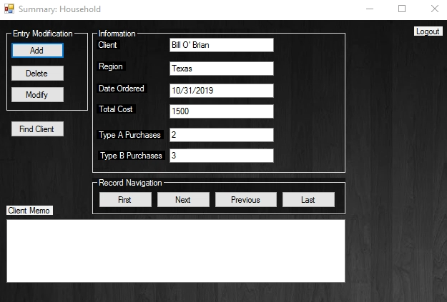
Figure 1
Once the respective logins are input, an employee from the household division will see a template as shown in Figure 1. They will have access to adding, deleting, modifying, finding, and scrolling through every customer within the division and act necessarily. When the modification buttons are clicked upon, the change of values will not only reflect in the software but it will also translate to the actual database (Excel or Access). This way, the employees will have 2-way access to all of their data. The difference in the coding between military and all of the other divisions is the database that’s used to generate and assemble all of the data is in .csv format. On the contrary, the other divisions are powered through Microsoft Access. The coding mechanisms and the implementations between these divisions heavily vary, but the end result is precisely the same. However, the database that’s used to generate each division could vary and one could go from .csv to Microsoft Access.
The client memo portion of the visual will display specific notes or comments that the employee needs to know regarding the respective customer on the list. These spaces will be unique based on the division. The logout button on the upper right corner takes the user back to the home page upon click. As a result, if a new user needs to access a different division, they will simply have to input their login details.

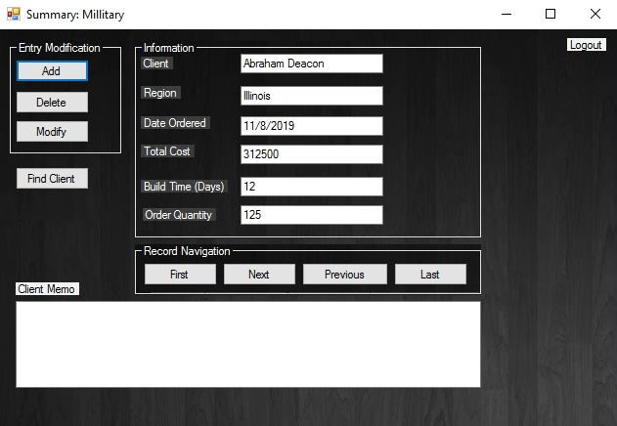
Figure 2
Once the respective logins are input, an employee from the military division will see a template as shown in Figure 2. They will have access to adding, deleting, modifying, finding, and scrolling through every customer within the division and act necessarily.

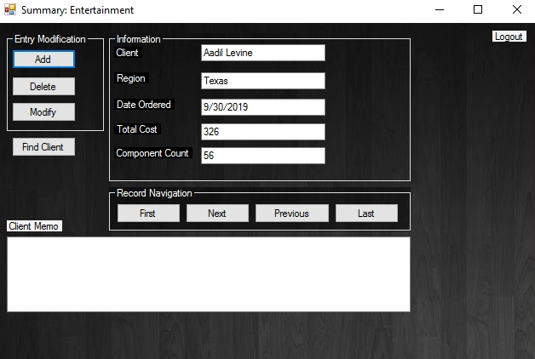
Figure 3
Once the respective logins are input, an employee from the entertainment division will see a template as shown in Figure 3. They will have access to adding, deleting, modifying, finding, and scrolling through every customer within the division and act necessarily.

- Manager Summary Tab
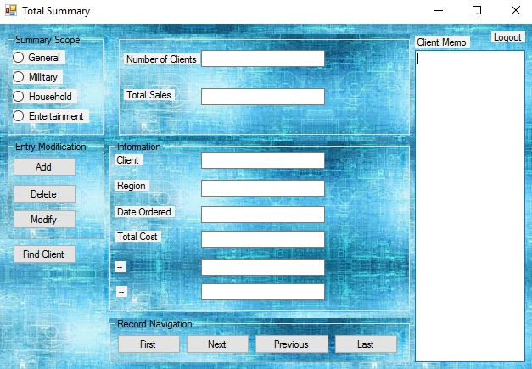
Figure 4 (Upcoming In 2020)
Once the respective logins are input, the manager will see a template as shown in Figure 4. They will have access to adding, deleting, modifying, finding, and scrolling through every customer within every division and act necessarily.
- Customer Tab
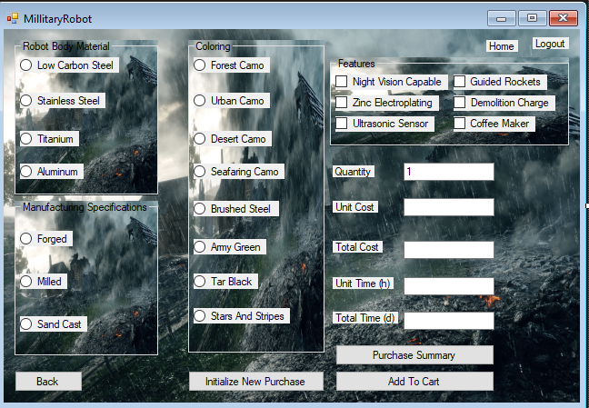
Figure 5
After a customer logs in to the database, they will be greeted by a home page that gives three options to choose from (3 divisions). Upon clicking one of the divisions, the customer will be navigated to the corresponding sales pages as shown above. In this instance, the military sales page offers a wide variety of options for personalization.
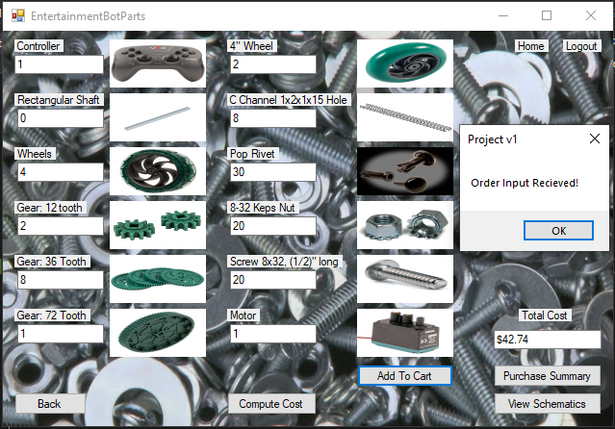
Figure 6
Once the customer “add[s] to cart” the products that they wish to purchase, upon clicking “home,” they are taken back to the homepage to make selections from the other divisions. In this instance, the entertainment sales page offers a variety of options discussed in the previous paragraphs regarding the specifications of these robots.
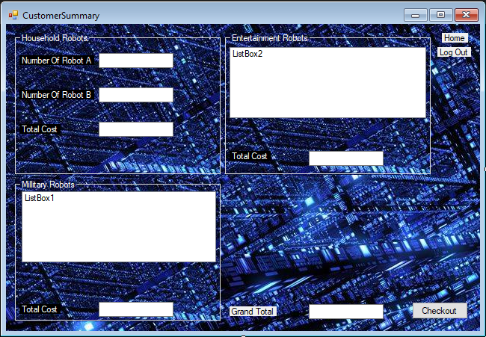
Figure 7
After the addition of all of the items that the customer seeks to purchase, the customer summary page will summarize all of the necessary details. Each purchase from the respective divisions will be displayed in the style shown in Figure 7, and the price tags will be displayed through textboxes, such as the instance in “Grand Total” and “Total Cost”. Upon clicking the checkout button, the customer will be redirected to pay for their products. Since all of these items have been previously saved, the customer can at any time go back to the homepage by clicking “Home” and continue to add more products into their shopping carts. As a result, they would have to recycle through all of these steps listed previously. Once the “Checkout” tab is clicked, the customer will be prompted to enter their credit card details and will be given a final confirmation upon their purchase.
Conclusion & Future Directions

Given the circumstances that led to Nuts & Bolts undertaking a new database structure, the business as a result prevailed. Having the ability to direct target the best suitors for their materials allowed for the increase of efficiency and allowed smart allocation of financial funds to benefit the company as a whole. To better commercialize the system that’s currently in place, Nuts & Bolts will plan to make adjustments and license the database to rivaling companies starting the beginning of 2022. The commercialization of an advandanced database will give Nuts & Bolts an extra source of income and a strong share in the database sector. A company who’s a part of the commercialized manufacturing sector will contain more relevant and up to date database structures than 3rd party sources, and that will be a solid selling point when trying to commercialize the database to potential suitors.

Apart from the future of the company in terms of database commercialization, Nuts & Bolts will add a variety of different robots to supply its customer’s needs. There will be separate problems such as quality & inventory control that will be brought up and prioritized for certain amount of these robots. Products themselves will include medical and industrial robots that range from welding, painting, material handling to a SCARA (Selective Compliance Robot Assembly Arm).

However, the most revolutionary aspect of Nuts & Bolts will be to create personalized products that won’t be commercially available. As a result, customers will not be limited to a list of options that the company offers. Whenever a problem arises, the consulting team of Nuts & Bolts will meet with upper representatives from the companies of potential suitors and list out the engineering parameters and realistic scenarios to better accommodate their needs. Once a prototype is designed, the finance team will determine the average cost and pricing plans to help the customers pay their dues in a timely fashion.

Appendix
Form 1

Public Class FormLogin
Private Sub Button1_Click(sender As Object, e As EventArgs) Handles Button1.Click
Select Case True
Case TextBox1.Text = "Customer" And TextBox2.Text = "Generic"
TextBox1.Text = ""
TextBox2.Text = ""
Me.Hide()
Home_Page.Show()
Case TextBox1.Text = "Employee" And TextBox2.Text = "Household"
TextBox1.Text = ""
TextBox2.Text = ""
Me.Hide()
HouseholdSummary.Show()
Case TextBox1.Text = "Employee" And TextBox2.Text = "Millitary"
TextBox1.Text = ""
TextBox2.Text = ""
Me.Hide()
MillitarySummary.Show()
Case TextBox1.Text = "Employee" And TextBox2.Text = "Entertainment"
TextBox1.Text = ""
TextBox2.Text = ""
Me.Hide()
EntertainmentSummary.Show()
Case TextBox1.Text = "Manager" And TextBox2.Text = "Showtime"
TextBox1.Text = ""
TextBox2.Text = ""
MsgBox("Manager Feature Under Maintnance. Coming Soon!" & vbNewLine & "Please login as either a customer or employee")
Case TextBox1.Text = "" Or TextBox2.Text = ""
MsgBox("Please fill in all information")
Case Else
MsgBox("Username or password is incorrect")
TextBox2.Text = ""
End Select
End Sub

Private Sub FormLogin_Load(sender As Object, e As EventArgs) Handles MyBase.Load
Call FormPictures()
End Sub
End Class

Form 2

Public Class Home_Page
Private Sub Label1_Click(sender As Object, e As EventArgs) Handles Label1.Click
Call Restart()
End Sub

Private Sub PictureBox1_Click(sender As Object, e As EventArgs) Handles PictureBox1.Click
Me.Hide()
FormMillitary.Show()
End Sub

Private Sub PictureBox2_Click(sender As Object, e As EventArgs) Handles PictureBox2.Click
Me.Hide()
FormHousehold.Show()
End Sub

Private Sub PictureBox3_Click(sender As Object, e As EventArgs) Handles PictureBox3.Click
Me.Hide()
FormEntertainment.Show()
End Sub

Private Sub Home_Page_Load(sender As Object, e As EventArgs) Handles MyBase.Load

End Sub
End Class

Form 3

Public Class FormEntertainment
Private I As Integer
Private Sub Label1_Click(sender As Object, e As EventArgs) Handles Label1.Click
Call Restart()
End Sub

Private Sub Label2_Click(sender As Object, e As EventArgs) Handles Label2.Click
Me.Hide()
Home_Page.Show()
End Sub

Private Sub Button1_Click(sender As Object, e As EventArgs) Handles Button1.Click
Me.Hide()
EntertainmentBotParts.Show()
End Sub

Private Sub Button2_Click(sender As Object, e As EventArgs) Handles Button2.Click
Me.Hide()
Schematics.Show()
End Sub

Private Sub FormEntertainment_Load(sender As Object, e As EventArgs) Handles MyBase.Load
I = 0
PictureBox2.Load(EPics(I))
End Sub

Private Sub Timer1_Tick(sender As Object, e As EventArgs) Handles Timer1.Tick
If I < 2 Then
I = I + 1
PictureBox2.Load(EPics(I))
Else
I = 0
PictureBox2.Load(EPics(I))
End If
End Sub
End Class

Form 4

Public Class EntertainmentBotParts
Private ECost, Parts As Double
Private I As Integer
Private Sub Button1_Click(sender As Object, e As EventArgs) Handles Button1.Click
Me.Hide()
FormEntertainment.Show()
End Sub

Private Sub Button2_Click(sender As Object, e As EventArgs) Handles Button2.Click
Me.Hide()
Schematics.Show()
End Sub

Private Sub Button4_Click(sender As Object, e As EventArgs) Handles Button4.Click
Me.Hide()
CustomerSummary.Show()
End Sub

Private Sub Label14_Click(sender As Object, e As EventArgs) Handles Label14.Click
Me.Hide()
Home_Page.Show()
End Sub

Private Sub Label15_Click(sender As Object, e As EventArgs) Handles Label15.Click
Call Restart()
End Sub

Private Sub Button5_Click(sender As Object, e As EventArgs) Handles Button5.Click
'Calculates Total Cost

Parts = CDbl(TextBox1.Text) + CDbl(TextBox2.Text) + CDbl(TextBox3.Text) + CDbl(TextBox4.Text) + CDbl(TextBox5.Text) + CDbl(TextBox6.Text) + CDbl(TextBox7.Text) + CDbl(TextBox8.Text) + CDbl(TextBox9.Text) + CDbl(TextBox10.Text) + CDbl(TextBox11.Text) + CDbl(TextBox12.Text)
ECost = CInt(TextBox1.Text) * 10 + CInt(TextBox2.Text) * 0.5 + CInt(TextBox3.Text) * 2 + CInt(TextBox4.Text) * 0.25 + CInt(TextBox5.Text) * 0.33 + CInt(TextBox6.Text) * 0.5 + CInt(TextBox7.Text) * 1.5 + CInt(TextBox8.Text) * 1 + CInt(TextBox9.Text) * 0.05 + CInt(TextBox10.Text) * 0.08 + CInt(TextBox11.Text) * 0.1 + CInt(TextBox12.Text) * 5
TextBox13.Text = Format(ECost, "$.00")
End Sub

Private Sub Button5_C()
'Lets button 3 call button 5
Parts = CDbl(TextBox1.Text) + CDbl(TextBox2.Text) + CDbl(TextBox3.Text) + CDbl(TextBox4.Text) + CDbl(TextBox5.Text) + CDbl(TextBox6.Text) + CDbl(TextBox7.Text) + CDbl(TextBox8.Text) + CDbl(TextBox9.Text) + CDbl(TextBox10.Text) + CDbl(TextBox11.Text) + CDbl(TextBox12.Text)
ECost = CInt(TextBox1.Text) * 10 + CInt(TextBox2.Text) * 0.5 + CInt(TextBox3.Text) * 2 + CInt(TextBox4.Text) * 0.25 + CInt(TextBox5.Text) * 0.33 + CInt(TextBox6.Text) * 0.5 + CInt(TextBox7.Text) * 1.5 + CInt(TextBox8.Text) * 1 + CInt(TextBox9.Text) * 0.05 + CInt(TextBox10.Text) * 0.08 + CInt(TextBox11.Text) * 0.1 + CInt(TextBox12.Text) * 5
TextBox13.Text = Format(ECost, "$.00")
End Sub
Private Sub Button3_Click(sender As Object, e As EventArgs) Handles Button3.Click
Call Button5_C()

If I = 0 Then
ETCost = ECost
EParts = Parts
MsgBox("Order Input Recieved!")
I = 1
Else
ETCost = ECost
EParts = Parts
MsgBox("Order Changed!")
End If

C1 = TextBox1.Text
C2 = TextBox2.Text
C3 = TextBox3.Text
C4 = TextBox4.Text
C5 = TextBox5.Text
C6 = TextBox6.Text
C7 = TextBox7.Text
C88 = TextBox8.Text
C9 = TextBox9.Text
C10 = TextBox10.Text
C11 = TextBox11.Text
C12 = TextBox12.Text

End Sub
End Class

Form 5

Public Class Schematics
Private Sub Button1_Click(sender As Object, e As EventArgs) Handles Button1.Click
Me.Hide()
EntertainmentBotParts.Show()
End Sub

Private Sub Label1_Click(sender As Object, e As EventArgs) Handles Label1.Click
Call Restart()
End Sub

Private Sub Label2_Click(sender As Object, e As EventArgs) Handles Label2.Click
Me.Hide()
FormEntertainment.Show()
End Sub
End Class

Form 6

Public Class FormMillitary
Dim I As Integer
Private Sub Label1_Click(sender As Object, e As EventArgs) Handles Label1.Click
Call Restart()
End Sub

Private Sub Label2_Click(sender As Object, e As EventArgs) Handles Label2.Click
Me.Hide()
Home_Page.Show()
End Sub

Private Sub Button1_Click(sender As Object, e As EventArgs) Handles Button1.Click
Me.Hide()
Form_MillitaryRobot.Show()
End Sub

Private Sub Timer1_Tick(sender As Object, e As EventArgs) Handles Timer1.Tick
If I < 2 Then
I = I + 1
PictureBox2.Load(MPics(I))
Else
I = 0
PictureBox2.Load(MPics(I))
End If
End Sub

Private Sub FormMillitary_Load(sender As Object, e As EventArgs) Handles MyBase.Load
I = 0
PictureBox2.Load(MPics(I))
End Sub
End Class

Form 7

Public Class Form_MillitaryRobot
Private Material, Manufacturing, Coloring, Features As Integer
Private Cost, TCost As Double
Private T1, T2, T3, T4, Time, TTime As Double

Private Sub Button1_Click(sender As Object, e As EventArgs) Handles Button1.Click
Me.Hide()
FormMillitary.Show()
End Sub

Private Sub Button2_Click(sender As Object, e As EventArgs) Handles Button2.Click
Me.Hide()
CustomerSummary.Show()
End Sub

Private Sub Button4_Click(sender As Object, e As EventArgs) Handles Button4.Click
TextBox1.Text = 1
RadioButton1.Checked = True
RadioButton11.Checked = True
RadioButton8.Checked = True
CheckBox1.Checked = False
CheckBox2.Checked = False
CheckBox3.Checked = False
CheckBox4.Checked = False
CheckBox5.Checked = False
CheckBox6.Checked = False
Call TextBoxInput()

End Sub

Private Sub Button3_Click(sender As Object, e As EventArgs) Handles Button3.Click
'Adds contents to database used on Millitary Summary, Customer Summary, and Manager Summary

MBuildTime = Time
MTCost = MTCost + TCost
MAQuantity = CInt(TextBox1.Text)
MQuantity = CInt(TextBox1.Text) + MQuantity
MsgBox("Order Recieved!")

ReDim Preserve MQ(0 To Mn)
ReDim Preserve MC(0 To Mn)
ReDim Preserve MT(0 To Mn)
MQ(Mn) = MAQuantity
MC(Mn) = TCost
MT(Mn) = MBuildTime

Mn = Mn + 1

End Sub

Private Sub Label2_Click(sender As Object, e As EventArgs) Handles Label2.Click
Me.Hide()
Home_Page.Show()
End Sub

Private Sub Label1_Click(sender As Object, e As EventArgs) Handles Label1.Click
Call Restart()
End Sub

Private Sub Form_MillitaryRobot_Load(sender As Object, e As EventArgs) Handles MyBase.Load
RadioButton1.Checked = True
RadioButton11.Checked = True
RadioButton8.Checked = True
End Sub

Private Sub Group1(sender As Object, e As EventArgs) Handles RadioButton1.CheckedChanged, RadioButton2.CheckedChanged, RadioButton3.CheckedChanged, RadioButton4.CheckedChanged
Select Case True
Case RadioButton1.Checked
Material = 500
T1 = 30 / 60
Case RadioButton2.Checked
Material = 700
T1 = 35 / 60
Case RadioButton3.Checked
Material = 1000
T1 = 40 / 60
Case RadioButton4.Checked
Material = 750
T1 = 60 / 60
End Select

Call TextBoxInput()
End Sub

Private Sub Group2(sender As Object, e As EventArgs) Handles RadioButton9.CheckedChanged, RadioButton10.CheckedChanged, RadioButton11.CheckedChanged
Select Case True
Case RadioButton9.Checked
Manufacturing = 800
T2 = (T1 * 1)
Case RadioButton10.Checked
Manufacturing = 600
T2 = (T1 * 0.5)
Case RadioButton11.Checked
Manufacturing = 500
T2 = (T1 * 0.25)
End Select
Call TextBoxInput()
End Sub

Private Sub Group3(sender As Object, e As EventArgs) Handles RadioButton5.CheckedChanged, RadioButton6.CheckedChanged, RadioButton7.CheckedChanged, RadioButton8.CheckedChanged, RadioButton13.CheckedChanged, RadioButton15.CheckedChanged, RadioButton16.CheckedChanged, RadioButton17.CheckedChanged
Select Case True
Case RadioButton5.Checked
Coloring = 250
T3 = 15 / 60
Case RadioButton6.Checked
Coloring = 250
T3 = 15 / 60
Case RadioButton7.Checked
Coloring = 250
T3 = 15 / 60
Case RadioButton8.Checked
Coloring = 250
T3 = 15 / 60
Case RadioButton13.Checked
Coloring = 200
T3 = 7.5 / 60
Case RadioButton15.Checked
Coloring = 300
T3 = 20 / 60
Case RadioButton16.Checked
Coloring = 200
T3 = 5 / 60
Case RadioButton17.Checked
Coloring = 200
T3 = 7.5 / 60
End Select
Call TextBoxInput()
End Sub

Private Sub Group4(sender As Object, e As EventArgs) Handles CheckBox1.CheckedChanged, CheckBox2.CheckedChanged, CheckBox3.CheckedChanged, CheckBox4.CheckedChanged, CheckBox5.CheckedChanged, CheckBox6.CheckedChanged
Dim F1, F2, F3, F4, F5, F6 As Integer
Dim TF1, TF2, TF3, TF4, TF5, TF6 As Double
If CheckBox1.Checked = True Then
F1 = 150
TF1 = 5 / 60
ElseIf CheckBox1.Checked = False Then
F1 = 0
TF1 = 0
End If

If CheckBox2.Checked = True Then
F2 = 275
TF2 = 1 / 3
ElseIf CheckBox2.Checked = False Then
F2 = 0
TF2 = 0
End If

If CheckBox3.Checked = True Then
F3 = 500
TF3 = 1 / 6
ElseIf CheckBox3.Checked = False Then
F3 = 0
TF3 = 0
End If

If CheckBox4.Checked = True Then
F4 = 2000
TF4 = 1 / 6
ElseIf CheckBox4.Checked = False Then
F4 = 0
TF4 = 0
End If

If CheckBox5.Checked = True Then
F5 = 75
TF5 = 1 / 4
ElseIf CheckBox5.Checked = False Then
F5 = 0
TF5 = 0
End If

If CheckBox6.Checked = True Then
F6 = 40
TF6 = 5 / 60
ElseIf CheckBox6.Checked = False Then
F6 = 0
TF6 = 0
End If

Features = F1 + F2 + F3 + F4 + F5 + F6
T4 = TF1 + TF2 + TF3 + TF4 + TF5 + TF6
Call TextBoxInput()
End Sub

Private Sub TextBoxInput()
Time = T1 + T2 + T3 + T4
Time = Math.Round(Time, 2)
Cost = Material + Manufacturing + Coloring + Features
Cost = Math.Round(Cost, 2)
TTime = (Time * CInt(TextBox1.Text)) / 8
TTime = Math.Round(TTime, 2)
TCost = Cost * CInt(TextBox1.Text)
TCost = Math.Round(TCost, 2)
TextBox2.Text = "$" & CStr(Cost)
TextBox3.Text = "$" & CStr(TCost)
TextBox4.Text = CStr(Time) & "hr"
TextBox5.Text = CStr(TTime) & "d"
End Sub

Private Sub TextBox1_TextChanged(sender As Object, e As EventArgs) Handles TextBox1.TextChanged
If TextBox1.Text = "" Then
TextBox1.Text = "1"
End If

Call TextBoxInput()
End Sub
End Class

Form 8

Public Class FormHousehold
Private I As Integer
Private Sub Label1_Click(sender As Object, e As EventArgs) Handles Label1.Click
Call Restart()
End Sub

Private Sub Label2_Click(sender As Object, e As EventArgs) Handles Label2.Click
Me.Hide()
Home_Page.Show()
End Sub

Private Sub Button3_Click(sender As Object, e As EventArgs) Handles Button3.Click
Me.Hide()
HouseHoldRobotA.Show()
End Sub

Private Sub Button4_Click(sender As Object, e As EventArgs) Handles Button4.Click
Me.Hide()
HouseHoldRobotB.Show()
End Sub

Private Sub FormHousehold_Load(sender As Object, e As EventArgs) Handles MyBase.Load
I = 0
PictureBox2.Load(HPics(I))
End Sub

Private Sub Button2_Click(sender As Object, e As EventArgs) Handles Button2.Click

If I < 2 Then
I = I + 1
PictureBox2.Load(HPics(I))
Else
I = 0
PictureBox2.Load(HPics((I)))
End If
End Sub

Private Sub Button1_Click(sender As Object, e As EventArgs) Handles Button1.Click
If I > 0 Then
I = I - 1
PictureBox2.Load(HPics(I))
Else
I = 2
PictureBox2.Load(HPics((I)))
End If
End Sub
End Class

Form 9

Public Class HouseHoldRobotA
Private Sub Button1_Click(sender As Object, e As EventArgs) Handles Button1.Click
Me.Hide()
FormHousehold.Show()
End Sub

Private Sub Button2_Click(sender As Object, e As EventArgs) Handles Button2.Click
Me.Hide()
HouseHoldRobotB.Show()
End Sub

Private Sub Button4_Click(sender As Object, e As EventArgs) Handles Button4.Click
Me.Hide()
CustomerSummary.Show()
End Sub

Private Sub Label2_Click(sender As Object, e As EventArgs) Handles Label2.Click
Me.Hide()
Home_Page.Show()
End Sub

Private Sub Label1_Click(sender As Object, e As EventArgs) Handles Label1.Click
Call Restart()
End Sub

Private Sub Button3_Click(sender As Object, e As EventArgs) Handles Button3.Click
NRobotA = NRobotA + 1
Label3.Text = "Number Ordered: " & NRobotA
End Sub

Private Sub Button5_Click(sender As Object, e As EventArgs) Handles Button5.Click
If NRobotA > 0 Then
NRobotA = NRobotA - 1
Label3.Text = "Number Ordered: " & NRobotA
End If
End Sub
End Class

Form 10

Public Class HouseHoldRobotB
Private Sub Button1_Click(sender As Object, e As EventArgs) Handles Button1.Click
Me.Hide()
FormHousehold.Show()
End Sub

Private Sub Button2_Click(sender As Object, e As EventArgs) Handles Button2.Click
Me.Hide()
HouseHoldRobotA.Show()
End Sub

Private Sub Button4_Click(sender As Object, e As EventArgs) Handles Button4.Click
Me.Hide()
CustomerSummary.Show()
End Sub

Private Sub Label2_Click(sender As Object, e As EventArgs) Handles Label2.Click
Me.Hide()
Home_Page.Show()
End Sub

Private Sub Label1_Click(sender As Object, e As EventArgs) Handles Label1.Click
Call Restart()
End Sub

Private Sub Button3_Click(sender As Object, e As EventArgs) Handles Button3.Click
NRobotB = NRobotB + 1
Label3.Text = "Number Ordered: " & NRobotB
End Sub

Private Sub Button5_Click(sender As Object, e As EventArgs) Handles Button5.Click
If NRobotB > 0 Then
NRobotB = NRobotB - 1
Label3.Text = "Number Ordered: " & NRobotB
End If
End Sub
End Class

Form 11

Public Class CustomerSummary
Private cost, GrandTotal As Double
Private Sub Label8_Click(sender As Object, e As EventArgs) Handles Label8.Click
Call Restart()
End Sub

Private Sub Label7_Click(sender As Object, e As EventArgs) Handles Label7.Click
Me.Close()
Home_Page.Show()
End Sub

Private Sub Button1_Click(sender As Object, e As EventArgs) Handles Button1.Click
Me.Close()
Checkout.Show()
End Sub

Private Sub TextBox3_TextChanged(sender As Object, e As EventArgs) Handles TextBox3.TextChanged

End Sub

Private Sub CustomerSummary_Load(sender As Object, e As EventArgs) Handles MyBase.Load

Dim T1 As Integer

TextBox1.Text = NRobotA
TextBox2.Text = NRobotB

TextBox1.Text = NRobotA
TextBox2.Text = NRobotB
cost = (NRobotA * 150) + (NRobotB * 400)
TextBox3.Text = Format(cost, "$.00")

TextBox4.Text = Format(MTCost, "$.00")
ListBox1.Items.Add("Order" & vbTab & "Quantity" & vbTab & "Time (d)" & vbTab & "Cost")

If Mn <> 0 Then
Do Until T1 = Mn
ListBox1.Items.Add(T1 + 1 & vbTab & MQ(T1) & vbTab & MT(T1) & vbTab & MC(T1) & vbNewLine)

T1 = T1 + 1
Loop
End If

TextBox5.Text = Format(ETCost, "$.00")

ListBox2.Items.Add("Item" & vbTab & vbTab & "Count")
ListBox2.Items.Add("Controller" & vbTab & vbTab & C1)
ListBox2.Items.Add("Shaft" & vbTab & vbTab & C2)
ListBox2.Items.Add("Wheels" & vbTab & vbTab & C3)
ListBox2.Items.Add("12 Tooth Gear" & vbTab & C4)
ListBox2.Items.Add("36 Tooth Gear" & vbTab & C5)
ListBox2.Items.Add("76 Tooth Gear" & vbTab & C6)
ListBox2.Items.Add("4in Wheel" & vbTab & C7)
ListBox2.Items.Add("C Chanel" & vbTab & vbTab & C88)
ListBox2.Items.Add("Pop Rivet" & vbTab & C9)
ListBox2.Items.Add("Keps Nuts" & vbTab & C10)
ListBox2.Items.Add("Screw" & vbTab & vbTab & C11)
ListBox2.Items.Add("Motor" & vbTab & vbTab & C12)

GrandTotal = cost + MTCost + ETCost
TextBox6.Text = Format(GrandTotal, "$.00")

End Sub

End Class

Form 12

Public Class Checkout
Private Sub Label8_Click(sender As Object, e As EventArgs) Handles Label8.Click
Call Restart()
End Sub

Private Sub Label7_Click(sender As Object, e As EventArgs) Handles Label7.Click
Me.Hide()
Home_Page.Show()
End Sub

Private Sub Button1_Click(sender As Object, e As EventArgs) Handles Button1.Click

If TextBox1.Text = "" Or TextBox2.Text = "" Or TextBox3.Text = "" Or TextBox4.Text = "" Or TextBox5.Text = "" Then
MsgBox("Please Fill In All Data")
ElseIf TextBox3.Text = TextBox4.Text Then
MsgBox("Purchase Successful!")
End
Else
MsgBox("Credit Card Number's Do Not Match!")
TextBox4.Text = ""

End If

'Adds customer information to ado files

'Use Customer Name, Region, Today's Date, Total Cost, and Number of Components
'Uses Textbox1.Text, Textbox2.Text, 11/26/19, ETCost, and EParts
If ETCost <> 0 Then

End If

'Use Customer Name, Region, Today's Date, Total Cost, Build Time, and order quantity
If MTCost <> 0 Then

End If

End Sub

End Class

Form 13

Public Class MillitarySummary
Private total As Integer
Private Sub Label1_Click(sender As Object, e As EventArgs) Handles Label1.Click
Call Restart()
End Sub

Private Sub MillitarySummary_Load(sender As Object, e As EventArgs) Handles MyBase.Load
'TODO: This line of code loads data into the 'DatabasesFP1DataSet.Military' table. You can move, or remove it, as needed.
Me.MilitaryTableAdapter.Fill(Me.DatabasesFP1DataSet.Military)

End Sub
Private Sub XABLE()
Button1.Enabled = True
Button2.Enabled = True
Button3.Enabled = True
Button4.Enabled = True
Button5.Enabled = True
Button6.Enabled = True
Button7.Enabled = True
Button8.Enabled = True

End Sub
Private Sub xDisABLE()
Button1.Enabled = False
Button2.Enabled = False
Button3.Enabled = False
Button4.Enabled = False
Button5.Enabled = False
Button6.Enabled = False
Button7.Enabled = False
Button8.Enabled = False
End Sub
Private Sub Button1_Click(sender As Object, e As EventArgs) Handles Button1.Click
'Add
If Button1.Text = "Add" Then
Call xDisABLE()
Button1.Enabled = True
Button1.Text = "Save"
MilitaryBindingSource.AddNew()

Else
MilitaryBindingSource.EndEdit()
MilitaryTableAdapter.Update(DatabasesFP1DataSet.Military)
Call XABLE()
Button1.Text = "Add"
total = total + 1
End If
End Sub
Private Sub Button2_Click(sender As Object, e As EventArgs) Handles Button2.Click
MilitaryBindingSource.RemoveCurrent()
MilitaryTableAdapter.Update(DatabasesFP1DataSet)
total = total - 1
End Sub
Private Sub Button3_Click(sender As Object, e As EventArgs) Handles Button3.Click
If Button3.Text = "Modify" Then
Call xDisABLE()
Button3.Enabled = True
Button3.Text = "Save"
Validate()

Else
MilitaryBindingSource.EndEdit()
MilitaryTableAdapter.Update(DatabasesFP1DataSet.Military)
Call XABLE()
Button3.Text = "Modify"
total = total + 1

End If
End Sub
Private Sub Button4_Click(sender As Object, e As EventArgs) Handles Button4.Click
MilitaryBindingSource.MoveFirst()
End Sub
Private Sub Button5_Click(sender As Object, e As EventArgs) Handles Button5.Click
Dim RecNum As Long
RecNum = MilitaryBindingSource.Position
If RecNum = total - 1 Then
Call Button4_Click(sender, e)
Else
MilitaryBindingSource.MoveNext()
End If
End Sub

Private Sub Button6_Click(sender As Object, e As EventArgs) Handles Button6.Click
MilitaryBindingSource.MovePrevious()
End Sub
Private Sub Button7_Click(sender As Object, e As EventArgs) Handles Button7.Click
MilitaryBindingSource.MoveLast()
End Sub

Private Sub Button8_Click(sender As Object, e As EventArgs) Handles Button8.Click
Dim K, Target As Long
Dim Userrep, Key As String
Userrep = CStr(InputBox("Enter a client"))

Target = -1
MilitaryBindingSource.MoveFirst()
For K = 0 To total - 1
key = DatabasesFP1DataSet.Military(K).Client
If Userrep = key Then
Target = K
Exit For
End If
MilitaryBindingSource.MoveNext()
Next
End Sub
End Class

Form 14

Public Class HouseholdSummary
Private Client(), ClientRegion(), DateOrdered() As String
Private TotalCost(), TypeA(), TypeB() As Integer
Private i, j, total As Integer

Private Sub HouseholdSummary_Load(sender As Object, e As EventArgs) Handles MyBase.Load
i = 0
j = 0
total = 0
'Read from the file - records
FileOpen(1, "Household.csv", OpenMode.Input)
Do Until EOF(1)
ReDim Preserve Client(0 To i)
ReDim Preserve ClientRegion(0 To i)
ReDim Preserve DateOrdered(0 To i)
ReDim Preserve TotalCost(0 To i)
ReDim Preserve TypeA(0 To i)
ReDim Preserve TypeB(0 To i)

Input(1, Client(i))
Input(1, ClientRegion(i))
Input(1, DateOrdered(i))
Input(1, TotalCost(i))
Input(1, TypeA(i))
Input(1, TypeB(i))

i = i + 1
Loop
FileClose(1)
total = i
End Sub
Private Sub xdisplay(ByVal target As Long)
TextBox1.Text = Client(target)
TextBox2.Text = ClientRegion(target)
TextBox3.Text = DateOrdered(target)
TextBox4.Text = TotalCost(target)
TextBox6.Text = TypeA(target)
TextBox7.Text = TypeB(target)
End Sub
Private Sub xdelete(ByVal Q As Integer)
Dim k As Integer

FileOpen(1, "Household.csv", OpenMode.Output)
For k = 0 To total - 1
If k <> Q Then
WriteLine(1, Client(k), ClientRegion(k), DateOrdered(k), TotalCost(k), TypeA(k), TypeB(k))
End If
Next
FileClose(1)
End Sub
Private Sub Button1_Click(sender As Object, e As EventArgs) Handles Button1.Click
Dim xClient, xClientRegion, xDateOrdered As String
Dim xTotalCost, xTypeA, xTypeB As Integer

xClient = TextBox1.Text
xClientRegion = TextBox2.Text
xDateOrdered = TextBox3.Text
xTotalCost = CInt(TextBox4.Text)
xTypeA = CInt(TextBox6.Text)
xTypeB = CInt(TextBox7.Text)

FileOpen(1, "Household.csv", OpenMode.Append)

WriteLine(1, xClient, xClientRegion, xDateOrdered, xTotalCost, xTypeA, xTypeB)
FileClose(1)
Call HouseholdSummary_Load(sender, e)
End Sub

Private Sub Button2_Click(sender As Object, e As EventArgs) Handles Button2.Click
Dim user As String
Dim k, target As Long
k = 0
user = InputBox("Enter a name")
target = -1
Do While k < total
If Client(k) = (user) Then
target = k
Call xdisplay(target)
Exit Do
End If
k = k + 1
Loop
If target = -1 Then
MsgBox("No such records")
End If

Call xdelete(target)

Call HouseholdSummary_Load(sender, e)
End Sub

Private Sub Button3_Click(sender As Object, e As EventArgs) Handles Button3.Click
Dim user As String
Dim k, target As Long
k = 0
user = InputBox("Enter a name")
target = -1
Do While k < total
If Client(k) = (user) Then
target = k
Call xdisplay(target)
Exit Do
End If
k = k + 1
Loop
If target = -1 Then
MsgBox("No such records")
End If

Client(target) = TextBox1.Text
ClientRegion(target) = TextBox2.Text
DateOrdered(target) = TextBox3.Text
TotalCost(target) = CInt(TextBox4.Text)
TypeA(target) = CInt(TextBox6.Text)
TypeB(target) = CInt(TextBox7.Text)
TextBox1.Text = ""
TextBox2.Text = ""
TextBox3.Text = ""
TextBox4.Text = ""
TextBox6.Text = ""
TextBox7.Text = ""
FileOpen(1, "Household.csv", OpenMode.Output)
For z = 0 To total - 1
WriteLine(1, Client(z), ClientRegion(z), DateOrdered(z), TotalCost(z), TypeA(z), TypeB(z))
Next
FileClose(1)
Call HouseholdSummary_Load(sender, e)
End Sub
Private Sub Button4_Click(sender As Object, e As EventArgs) Handles Button4.Click
Call xdisplay(0)
j = 0
End Sub
Private Sub Button5_Click(sender As Object, e As EventArgs) Handles Button5.Click
j = j + 1
If j = total Then
j = 0
End If
Call xdisplay(j)
End Sub
Private Sub Button6_Click(sender As Object, e As EventArgs) Handles Button6.Click
j = j - 1
If j = -1 Then
j = total - 1
End If
Call xdisplay(j)
End Sub
Private Sub Button7_Click(sender As Object, e As EventArgs) Handles Button7.Click
Call xdisplay(total - 1)
j = total
End Sub
Private Sub Button8_Click(sender As Object, e As EventArgs) Handles Button8.Click
Dim user As String
Dim k, target As Long
k = 0
user = InputBox("Enter a name")
target = -1
Do While k < total
If Client(k) = (user) Then
target = k
Call xdisplay(target)
Exit Do
End If
k = k + 1
Loop
If target = -1 Then
MsgBox("No such records")
End If
End Sub
End Class

Form 15

Public Class EntertainmentSummary
Private total As Integer
Private Sub Label1_Click(sender As Object, e As EventArgs) Handles Label1.Click
Call Restart()
End Sub

Private Sub EntertainmentSummary_Load(sender As Object, e As EventArgs) Handles MyBase.Load
'TODO: This line of code loads data into the 'DatabasesFP1DataSet.Entertainment' table. You can move, or remove it, as needed.
Me.EntertainmentTableAdapter.Fill(Me.DatabasesFP1DataSet.Entertainment)

End Sub

Private Sub XABLE()
Button1.Enabled = True
Button2.Enabled = True
Button3.Enabled = True
Button4.Enabled = True
Button5.Enabled = True
Button6.Enabled = True
Button7.Enabled = True
Button8.Enabled = True

End Sub
Private Sub xDisABLE()
Button1.Enabled = False
Button2.Enabled = False
Button3.Enabled = False
Button4.Enabled = False
Button5.Enabled = False
Button6.Enabled = False
Button7.Enabled = False
Button8.Enabled = False
End Sub
Private Sub Button1_Click(sender As Object, e As EventArgs) Handles Button1.Click
'Add
If Button1.Text = "Add" Then
Call xDisABLE()
Button1.Enabled = True
Button1.Text = "Save"
EntertainmentBindingSource.AddNew()

Else
EntertainmentBindingSource.EndEdit()
EntertainmentTableAdapter.Update(DatabasesFP1DataSet.Entertainment)
Call XABLE()
Button1.Text = "Add"
total = total + 1
End If
End Sub
Private Sub Button2_Click(sender As Object, e As EventArgs) Handles Button2.Click
EntertainmentBindingSource.RemoveCurrent()
EntertainmentTableAdapter.Update(DatabasesFP1DataSet)
total = total - 1
End Sub
Private Sub Button3_Click(sender As Object, e As EventArgs) Handles Button3.Click
If Button3.Text = "Modify" Then
Call xDisABLE()
Button3.Enabled = True
Button3.Text = "Save"
Validate()

Else
EntertainmentBindingSource.EndEdit()
EntertainmentTableAdapter.Update(DatabasesFP1DataSet.Entertainment)
Call XABLE()
Button3.Text = "Modify"
total = total + 1

End If
End Sub
Private Sub Button4_Click(sender As Object, e As EventArgs) Handles Button4.Click
EntertainmentBindingSource.MoveFirst()
End Sub
Private Sub Button5_Click(sender As Object, e As EventArgs) Handles Button5.Click
Dim RecNum As Long
RecNum = EntertainmentBindingSource.Position
If RecNum = total - 1 Then
Call Button4_Click(sender, e)
Else
EntertainmentBindingSource.MoveNext()
End If
End Sub

Private Sub Button6_Click(sender As Object, e As EventArgs) Handles Button6.Click
EntertainmentBindingSource.MovePrevious()
End Sub
Private Sub Button7_Click(sender As Object, e As EventArgs) Handles Button7.Click
EntertainmentBindingSource.MoveLast()
End Sub

Private Sub Button8_Click(sender As Object, e As EventArgs) Handles Button8.Click
Dim K, Target As Long
Dim Userrep, Key As String
Userrep = CStr(InputBox("Enter a client"))

Target = -1
EntertainmentBindingSource.MoveFirst()
For K = 0 To total - 1
Key = DatabasesFP1DataSet.Military(K).Client
If Userrep = Key Then
Target = K
Exit For
End If
EntertainmentBindingSource.MoveNext()
Next

End Sub
End Class

Form 16

None. This form serves visual purposes only.

Form 17

Module Module1
Public EPics(), MPics(), HPics() As String
Public a, b, c, EParts, NRobotA, NRobotB, MQuantity As Integer
Public ETCost, MBuildTime, MTCost As Double

Public MQ(), MT(), MC(), Mn As Double

Public C1, C2, C3, C4, C5, C6, C7, C8, C88, C9, C10, C11, C12, MAQuantity As Integer

Public Sub FormPictures()

FileOpen(1, “MillitaryPics.txt”, OpenMode.Input)

Do Until EOF(1)
ReDim Preserve MPics(0 To a)
Input(1, MPics(a))

a = a + 1
Loop
FileClose(1)

FileOpen(2, “HouseholdPics.txt”, OpenMode.Input)

Do Until EOF(2)
ReDim Preserve HPics(0 To b)
Input(2, HPics(b))

b = b + 1
Loop
FileClose(2)

FileOpen(3, “EntertainmentPics.txt”, OpenMode.Input)

Do Until EOF(3)
ReDim Preserve EPics(0 To c)
Input(3, EPics(c))

c = c + 1
Loop
FileClose(3)

End Sub

Public Sub Restart()
Application.Restart()
FormLogin.Show()
End Sub
End Module

